PROGRAM

Monday 20 May – Ancona
Participants’ arrival at Ancona by 1 p.m.: check in at the **** Hotel.
2 p.m. - Welcome cocktail at the Hotel.
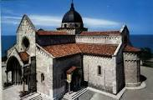
Following a brief presentation of the programme by the Club President Giancarlo Moroni. The walking tour of Ancona begins at 3.30 p.m :
the Old Town, the Roman Amphitheatre, St Ciriaco’s Cathedral (1000 A.D.), the Archaeological Museum, the Romanesque church of S. Maria della Piazza, Piazza Plebiscito, the church of St Domenico with paintings by Titian and Guercino, the Calamo Fountain, etc.
Return to the Hotel.
6.00 p.m. : Bus to Portonovo :Musical Show in Romanic Church of Holy Mary.
8,30.00 p.m. – Dinner at a typical Restaurant, in front of the beach.
Return to the Hotel: overnight stay.

Tuesday 21 May – Ascoli Piceno - Marche Sud
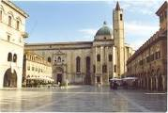
After breakfast in the Hotel Roof Garden, departure at 8.30 in a large tourer coach for the beautiful, historic town of Ascoli Piceno.
On arrival, a walking tour of the old centre, guided by the architect Valerio Borzacchini ( Past District Governor ) to see: the famous Piazza del Popolo (one of the most beautiful squares in Italy), the old Meletti Coffee House, Piazza Arringo, the Cathedral, the Ventidio Basso Theatre, the Roman Bridge (and its interior), etc.
Lunch at “Villa Picena”, a typical restaurant where guests can enjoy the local cuisine, such as traditional Ascoli olives.
In the afternoon, a visit to the Medieval Town of Offida, which is famous for its traditional production of lace and fine wines.
Return to Ancona.
Off evening. Overnight stay at the Hotel.

Wednesday 22 May – Marche and Nature
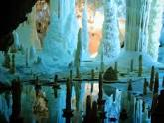
Breakfast at the Hotel.
Departure at 8,30 for Fabriano, center of Art and History. Visit of historic centre and Museum of Carta and Filigrana. Lunch in typical restaurant “Old railway “.
3,00 p.m. Departure to Gola della Rossa and the splendid underground Frasassi Caves. The Caves, of karstic formation, are in area of the town of Genga. The complex consists of a series of caves of which the first, which can be visited using the current entrance, is the Abisso Ancona (Ancona Abyss). It is 180 by 120 metres, reaching a height of 200 metres; in fact, it is over 2 million square metres and could easily contain Milan Cathedral.
Return to the Hotel.
Overnight stay.

Thursday 23 may - Fermo and Macerata
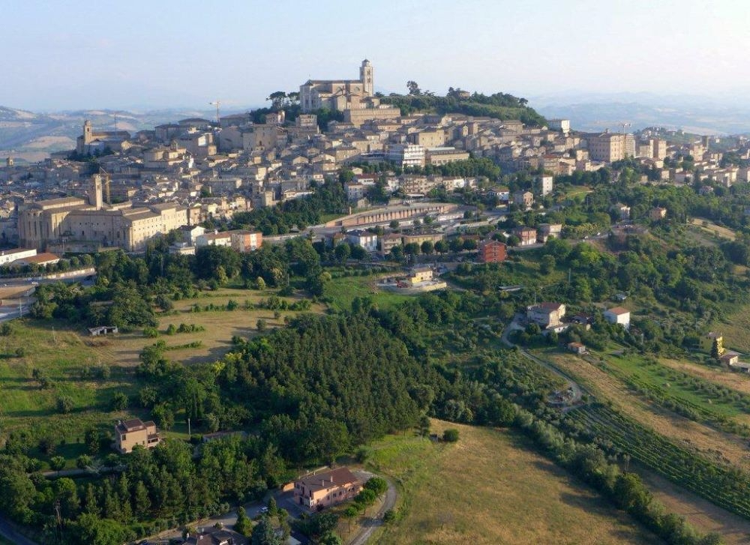
Breakfast in Hotel.
Departure at 8,30 to Fermo, roman and medieval city. Visit of historical Centre, Roman cistern,the Cathedral, Theatre of Aquila.
Free snack.
This will be followed, in early afternoon, by a visit to Romanic Abbeys of Santa Maria a Pie’ di Chienti and San Claudio.
Return to Ancona . Free afternoon.
8 p.m.Rotary evening : Dinner at the “ Fortino Napoleonico “ at Portonovo, beautiful place on the sea coast of Marche; there will be, with the district Governor, a presentation of the participants and pennants will be exchanged.
Return to the Hotel; overnight stay.

Friday 24 May - Urbino
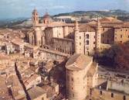
Breakfast at the Hotel.
Departure at 8,30 for Urbino, one of the most important centres of Renaissance Italy, and which has preserved its unique architecture. The old town has been a UNESCO World Heritage Centre since 1998.
Visit to the Ducal Palace, the Picture Gallery with several paintings by Raphael Sanzio and Piero della Francesca, the painter’s birthplace and the old town.
Lunch (with local, traditional cuisine).
Back to Ancona. Visit to Umani Ronchi winery, belonging to the family of Mr. Massimo Bernetti, founding partner of our Club. Tasting of their fine wines.
Return to the Hotel; Off evening. Overnight stay

Saturday 25 May – Cruise and Panoramas
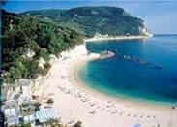
Breakfast at the Hotel.
Departure at 9 to the Port of Ancona for a cruise along the coast to see the Conero Riviera, the small towns of Sirolo and Numana and Portonovo Bay; the splendid Romanesque Chapel of Holy Mary at Portonovo, directly overlooking the sea, will complete the excursion.
An aperitif will be served on board: the cruise ends by 1,00 p.m..
If the weather is unsuitable, the cruise will be replaced by a visit to the famous Marian Sanctuary of Loreto.
1,00 p.m. good memory cocktail in Hotel.

Farewells and departures.

