Dear President,
Dear Secretary,
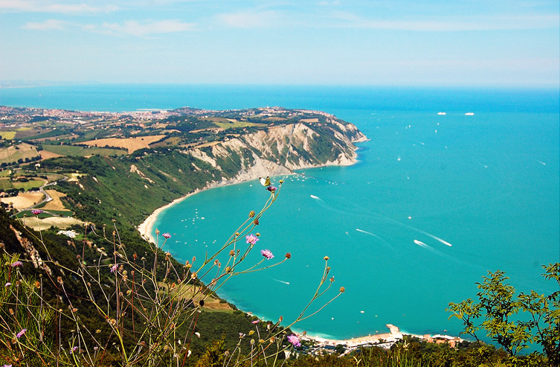
Following the enthusiastic feedback we received from participants in former editions, we are pleased to announce that the Rotary Club tour of the Marche’s “Hidden masterpieces” will take place this year too, from 20 to 25 May. This initiative, which our Club organizes in support of “END POLIO NOW”, is aimed at introducing members and their guests to the treasures of the Marche Region – its architecture, art, painting, nature, and cuisine. Even though the Marche is probably one of the less well-known among Italian regions, it encompasses the country’s most distinctive features; hence its definition as “Italy in one Region”. The initiative is a non-profit one . Residual amounts, if any, will be allocated to the Polioplus programme of the Rotary Foundation and Populations so hardly hit by earthquake in Middle Italy.

In the traditional Rotary Club spirit, we kindly ask you to inform your Club’s members about this initiative, so as to enable those among them who are interested in the Tour to make their reservation with us.

The Tour will start on Monday 20 May, in the afternoon, and will end on Saturday 25 May, in the morning. It includes accommodation in four stars Hotel in Ancona (double room with breakfast) from the night of 20 May to the morning of 25 May; the meals as set out in the programme (including drinks); the gala night on 23 May; and guided couch tours.
The fee is 990,00 euros per person.
Single rooms entail an additional cost of 200 euros.
No doubt the variety and prominence of the sites and works of art on the programme will impress our guests and leave them with unforgettable memories.

The maximum number of participants is 50; the initiative will be cancelled if the number of participants is below 30.
Attached you will find the detailed programme.
Should you have any further queries, feel free to contact Mr. Luigi Cafasi (Rotary Club Ancona-Conero) Tel. +39 3356404673 (luigicafasi@gmail.com).

Reservations can be made through the attached form and under the terms therein contained, sending a down payment of 400 euros per person by 22 March 2019.

The remaining amount will have to be paid by 26 April 2019 . The IBAN number for money transfers is indicated in the registration form.

We are making the utmost to organise a memorable Tour for our guests.

See you soon, then. With friendliest Rotary wishes.

Ancona, January 30th 2019

Rotary Club Ancona-Conero
The President
Giancarlo Moroni

